FLIPKART

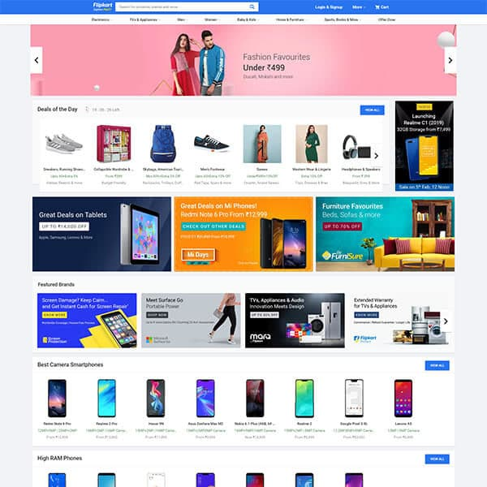

OVERVIEW:

Flipkart is an Indian private limited company with its headquarters in Bangalore and Singapore incorporation. Before branching out into other product categories like consumer electronics, fashion, household staples, food, and lifestyle goods, the company initially concentrated on online book sales.

The service's main rivals are Snapdeal in India and Amazon's Indian subsidiary. Flipkart controlled 39.5% of the Indian e-commerce market as of March 2017.

Flipkart was said to be "neck and neck" with Amazon in the selling of gadgets and mobile phones, and it has a commanding position in the fashion sector because to its purchase of Myntra.

Additionally, Flipkart is the owner of PhonePe, a UPI-based mobile payment platform. Flipkart was valued at roughly $20 billion when American retail giant Walmart purchased a 77% controlling share for US$16 billion in August 2018.

HISTORY:

Flipkart became founded in October 2007 through Sachin Bansal and Binny Bansal, alumni of the IIT Delhi and former Amazon personnel. The employer to start with targeted on online e-book income with USA-wide delivery. Flipkart slowly grew in prominence and changed into receiving 100 orders in line with day by 2008. In 2010, Flipkart acquired the Bangalore-based totally social book discovery service WeRead from Lulu.Com.

In 2011, Flipkart received the digital distribution commercial enterprise Mime360.Com and the digital content library of the Bollywood portal Chakpak. Following the acquisition, Flipkart launched their DRM-free on line tune shop Flyte in 2012. Due to competition from unfastened streaming websites, Flyte changed into unsuccessful and shut down in June 2013.

With its eyes on India's retail marketplace, Flipkart acquired Letsbuy, a web electronics store in 2012, and Myntra, a web style store, for US$280 million in May 2014. Myntra continues to function alongside Flipkart as a standalone subsidiary focusing on separate marketplace segments.

GOALS TO ACHIEVE:

* Sign up / Sign in Page
* Home Page / Front Page
* Item List Page
* Bill Page
* Payment Page

**HOME PAGE:**

* Logo
* Advertisement posters (images)
* Discounts (images)
* Search Bar
* Add to the Cart
* Slider
* Top Trends
* Footer (Contact us, branch office address, Help, About)

**REGISTRATION PAGE (or Sign up Page):**

* Mobile Number
* E mail Id
* Set Password
* OTP
* Flip Kart Plus

**ITEM’S LIST PAGE:**

1. Sort By:
   1. Top Trends
   2. Price low to high
   3. Price high to low
   4. Latest
2. Filter
   1. Brand
   2. Price
   3. Size
   4. Occasion
   5. Rating
   6. Discount Offers
   7. Availability
3. Different items are separated into divisions.
4. Details of the items( such as Name of the item, Price, Brand, Rating, Review).
5. Buy now/ Add to cart.
6. Different angles of the item and product description on clicking the image.
7. Compare.
8. Share.

**PAYMENT PAGE/ BILL PAGE:**

1. Bill Page:
   1. Name of the product
   2. Cost of the product
   3. Order Date
   4. Shipping charges
   5. Taxes
   6. Total Cost
2. Payment Method:
   1. Flip Kart Pay Later
   2. PhonePe (UPI, Wallet)
   3. Credit/ Debit/ ATM card
   4. Net Banking
   5. Cash on Delivery
   6. EMI
   7. Gift card

https://github.com/Gopu-Lalithya/project_flipkart